HUAWEI
FRD-L09C185B386
Software Upgrade Guideline

Prepared by | CMO | Date | 2017-7-4
Reviewed by | CMO | Date | 2017-7-4
Approved by | CMO | Date | 2017-7-4

Huawei Technologies Co., Ltd.
All rights reserved
Contents
Contents 2
1 Version introduction 3
1.1 The following versions can be upgraded. 3
1.2 Upgrade package 3
2 Upgrade environment requirements 3
2.1 Check current upgrade environment 3
3 Upgrade introduction 4
4 Upgrade operations 4
4.1 Normal upgrade 4
4.2 Force upgrade 5
4.3 Vendor package upgrade 6
4.4 Remarks 8
5 Upgrade validate 8
5.1 Check the version 8

Version introduction

The following versions can be upgraded.
Versions can be upgraded
FRD-L09C185B386 and below

Upgrade package
Upgrade package | Info
Main package | SDupdate_Package.tar.gz
Upgrade tools | Micro SD card

Upgrade environment requirements

Check current upgrade environment
- To make sure that the Micro SD card is available and can be read and write.
Notes: A Micro SD card of 8GB or more should be available. It is recommended that The Micro SD card is made by Sandisk, Kingstone, or Kingmax .
- To make sure that the power of the battery is enough to run the upgrade process. It is recommended that the power of the battery is more than 30%.
- Upgrade operations will erase all user data. So if there is some important information, you should backup them before upgrade.
- you should unzip the SDupdate_Package.tar.gz file, and get out UPDATE.APP to do upgrade operation, the file list as :

└─dload
├─hw
│ └─meafnaf
│ └─update_data_hw_meafnaf.app
├─UPDATE.APP

Upgrade introduction
There are two methods to upgrade: normal upgrade and force upgrade.
Normal upgrade needs to start the handset and enter the System Update module. Force upgrade is just used when the handset can’t boot up or can’t enter the idle screen.

Upgrade operations
Upgrade steps description.

Normal upgrade
- Format the Micro SD card (This operation is optional).
- Unzip SDupdate_Package.tar.gz
- Copy the entire dload folder (with UPDATE.APP in it) to the root directory of the Micro SD card. Check if the whole file list in sdcard,
Insert the Micro SD card into the handset and power on. After entering call -> enter:*#*#2846579#*#* -> ProjectMenu -> Software Upgrade -> SDCard Upgrade-> OK，
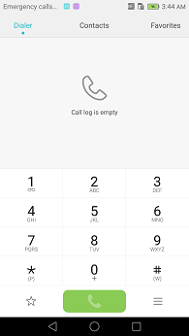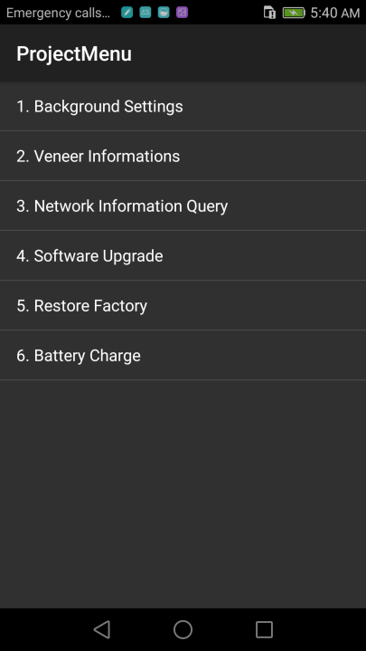

- When the progress bar stop, the phone will restart automatically.
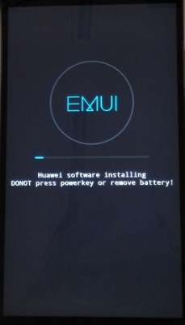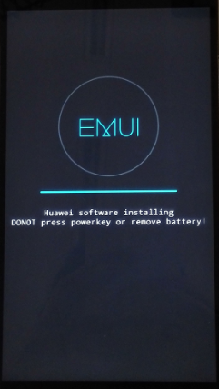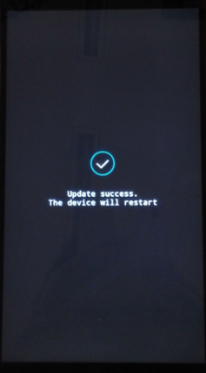

Vendor package upgrade
- Format the Micro SD card (This operation is optional).
- Copy the entire dload folder (with Vendor package UPDATE.APP in it) to the root directory of the Micro SD card. Check if the whole file list in sdcard,
Insert the Micro SD card into the handset and power on. After entering call -> enter:*#*#2846579#*#* -> ProjectMenu -> Software Upgrade -> SDCard Upgrade-> OK，

- When the progress bar stop, the phone will restart automatically.

- Manually restore the factory settings
enter:*#*#2846579#*#* -> ProjectMenu ->Restore Factory

Normal upgrade again
Step1. Repeat steps 4.1,ensure your DUT update success again

Force upgrade
Attention:
This step is optional, just after the 4.1 Normal upgrade can not be successfully,
Then You can use this upgrade instead of the normal upgrade!
- Format the Micro SD card (This operation is optional).
- Unzip SDupdate_Package.tar.gz
- Copy the entire dload folder (with UPDATE.APP in it) to the root directory of the Micro SD card. Check the file list is right.
- Make sure your handset is power off. Insert the Micro SD card into the handset. Press the VOLUME UP and VOLUME DOWN key, and then press the POWER key to power on the phone and enter the Software Upgrade Mode.
- When the progress bar stop, the phone will restart automatically.

Tips:
      - After powering on,it displays well in English.
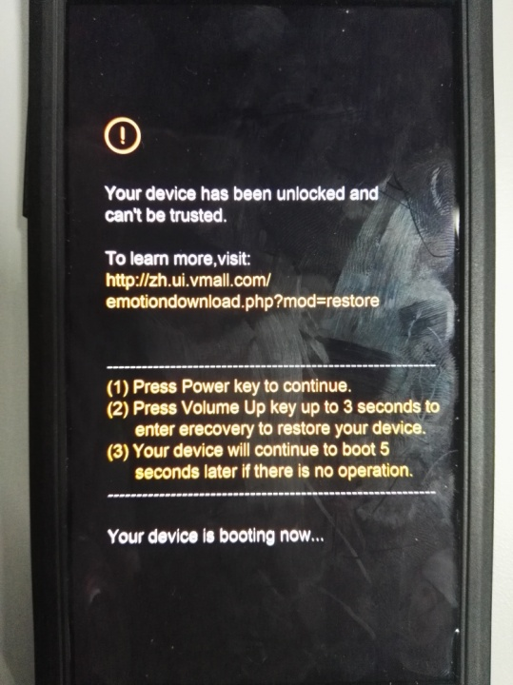

Upgrade validate

Check the version
      - By step: Settings->About phone->Build number, to check the version is correct or not.
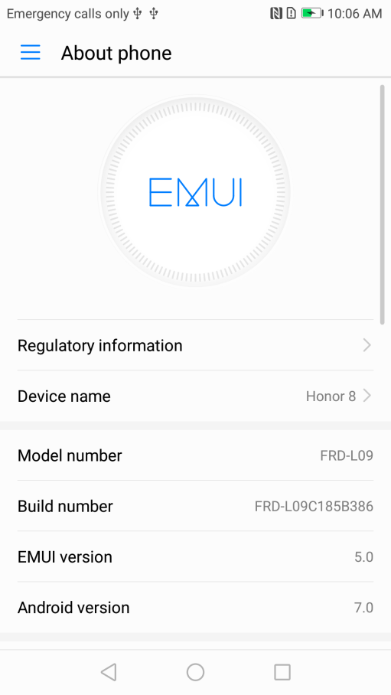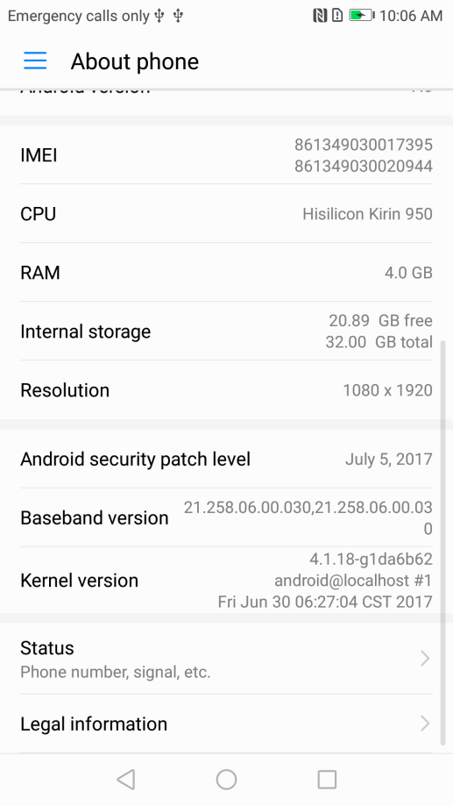
The build number is FRD-L09C185B386

