HUAWEI
VNS-L21C432B381
Software Upgrade Guideline

Prepared by | CMO | Date | 2017-04-18
Reviewed by | CMO | Date | 2017-04-18
Approved by | CMO | Date | 2017-04-18

Huawei Technologies Co., Ltd.
All rights reserved
Contents
1 Version introduction 3
1.1 The following versions can be upgraded. 3
1.2 Upgrade package 3
2 Upgrade Precautions 3
2.1 Check current upgrade environment 3
2.2 Backup your private data and get the right upgrade method 3
2.3 Get and check the software package 4
3 Upgrade introduction 4
4 Upgrade operations 4
4.1 Normal upgrade 4
4.2 Vendor package upgrade 6
4.3 Normal upgrade again 7
4.4 Force upgrade 7
5 Upgrade validate 9
5.1 Check the version 9

Version introduction

The following versions can be upgraded.
Versions can be upgraded
VNS-L21C432B371
VNS-L21C432B335
VNS-L21C432B161

Upgrade package
Upgrade package | Info
Main package | SDupdate_Package.rar
Upgrade tools | MicroSD card

Upgrade Precautions

Check current upgrade environment
Make sure that the MICRO SD card is available and can be read and write.

Backup your private data and get the right upgrade method
The upgrade process will erase the user data, and please backup your data before upgrade.
If your current software was android 6.x version, you must update the transfer package first which was released in the Huawei official website.
If your current software was android 7.0 version, you should backup your data before upgrade.
You can get the android version number as chapter 5.1- Check the version.

Get and check the software package
There are two software package: main package and vendor package.

Upgrade introduction
There are two methods to upgrade: normal upgrade and force upgrade.
Normal upgrade needs to start the handset and enter the System Update module. Force upgrade is justused when the handset can’t boot up or can’t enter the idle screen.

Upgrade operations
First refer the current android version number as chapter 2.2 to check whether it need transfer package or not

Normal upgrade
- Format the Micro SD card (This operation is optional).
- Unzip SDupdate_Package.rar
- Copy the entire dload folder (with UPDATE.APP in it) to the root directory of the Micro SD card. Check if the whole file list in sdcard,
Insert the Micro SD card into the handset and power on. After entering call ->enter:*#*#2846579#*#* ->ProjectMenu->Software Upgrade->SDCard Upgrade->OK，
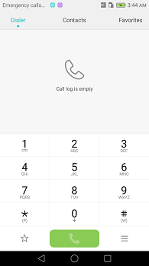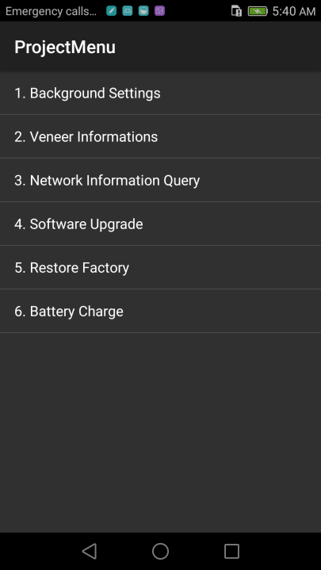

- When the progress bar stop, the phone will restart automatically.
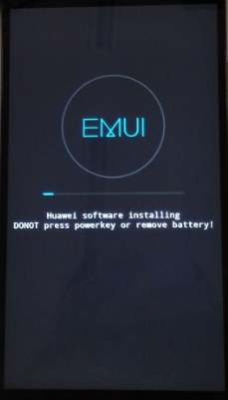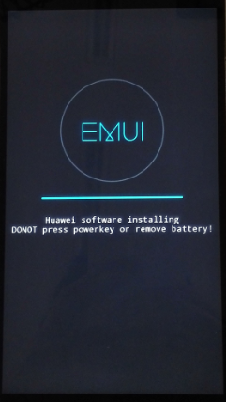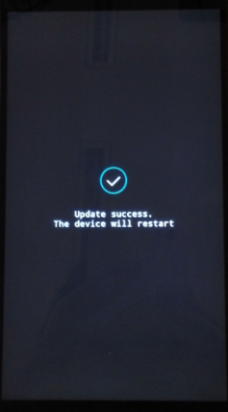

Vendor package upgrade
- A MICRO SD card of 8GB or more should be available. The MICRO SD card made by Sandisk, Kingstone, or Kingmax is recommended.
- Format the Micro SD card (This operation is optional).
- Copy the entire dload folder (with Vendor package UPDATE.APP in it) to the root directory of the Micro SD card. Check if the whole file list in sdcard,
Insert the Micro SD card into the handset and power on. After entering call ->enter:*#*#2846579#*#* ->ProjectMenu->Software Upgrade->SDCard Upgrade->OK，

- When the progress bar stop, the phone will restart automatically.

- Manually restore the factory settings
enter: Settings -> Advanced settings ->Backup & reset ->Factory data reset ->Reset phone ->Reset phone

Normal upgrade again
Step1. Repeat steps 4.1, ensure your DUT update success again

Force upgrade
Attention:
This step is optional, just after the 4.1 Normal upgrade cannot be successfully,
Then you can use this upgrade instead of the normal upgrade!
- A MICRO SD card of 8GB or more should be available. The MICRO SD card made by Sandisk, Kingstone, or Kingmax is recommended.
- Format the Micro SD card (This operation is optional).
- Unzip SDupdate_Package.rar
- Copy the entire dload folder (with UPDATE.APP in it) to the rootdirectory of the Micro SD card. Check the file list is right.
- Make sure your handset is power off. Insert the Micro SD card into the handset. Press the VOLUME UP and VOLUME DOWN key, and then press the POWER key to power on the phone and enter the Software Upgrade Mode.
- When the progress bar stop, the phone will restart automatically.
Tips:
      - After powering on,it displays well in English.
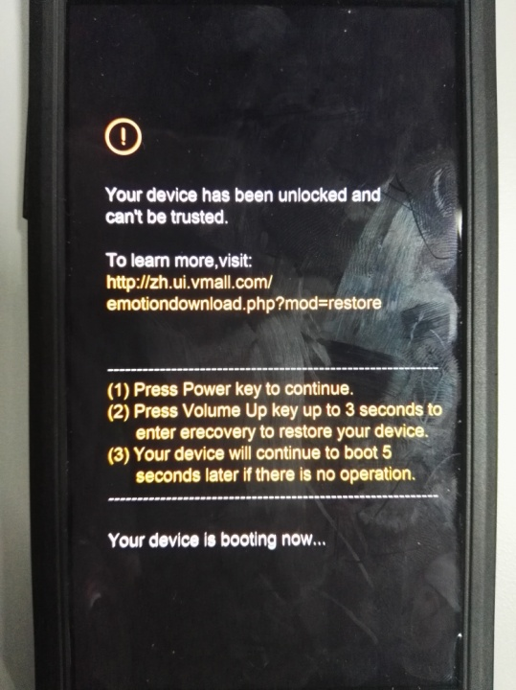

Upgrade validate

Check the version
      - By step:Settings->About phone->Build number, to check the versionis correct or not.
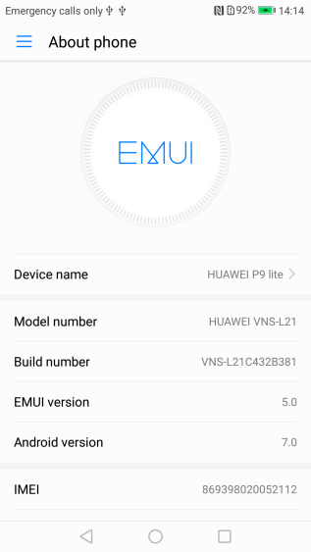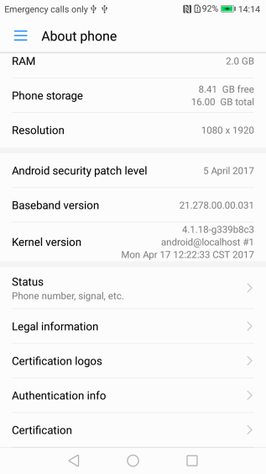
The build number is VNS-L21C432B381

